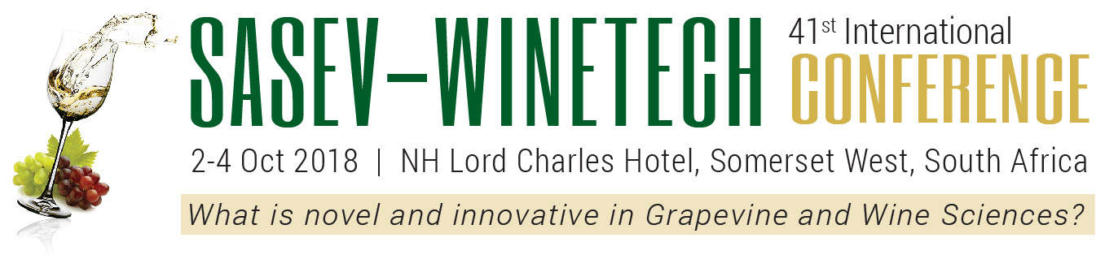PRELIMINARY REGISTRATION FORM
SURNAME Click here to type
FIRST NAME Click here to type
ATTENTION
Please send completed form and your payment on or before 21 September 2018.
R200.00 Administration fee on cancellations after 21/09/2018.
Last registration and no reimbursement after 21/09/2018.
(For name-tag)
INITIALS Click here to type
TITLE Click here to type
COMPANY Click here to type
POSITION Click here to type
(If a full-time student, indicate so as position)
E-MAIL Click here to type
MOBILE Click here to type
ADDRESS Click here to type
Click here to type POSTAL CODE : Click here to type
SUPERVISOR CONFIRMATION FOR FULL-TIME STUDENTS
Please indicate which EVENT(S) you are booking for: Fees (amount quoted in South African Rand – ZAR)
OPEN SESSIONS |  | STUDENTS & SASEV HONOURLY MEMBERS | SASEV MEMBERS | NON MEMBERS | TOTAL
Session 1 – Tuesday, 2 October 2018 |  | R520.00 | R650.00 | R850.00 | R (Click here to type)
Session 2 – Wednesday, 3 October 2018 |  | R520.00 | R650.00 | R850.00 | R (Click here to type)
Session 3 – Thursday, 4 October 2018 |  | R520.00 | R650.00 | R850.00 | R (Click here to type)
Sessions 1, 2 & 3 |  | R1 050.00 | R1 300.00 | R2 100.00 | R (Click here to type)
WORKSHOPS (Please indicate which workshops)
Tuesday  2 October | W01: Rapid sensory profiling solutions for industry applications | R440.00 | R550.00 | R750.00 | R (Click here to type)
 | W02: Alternative Trellis Systems – making the right choice | R440.00 | R550.00 | R750.00 | R (Click here to type)
 | W03: Rapid, Optical Method for Phenolic Profiling and Classification... | R440.00 | R550.00 | R750.00 | R (Click here to type)
Wednesday  3 October | W04: Unlocking value in South Africa’s old vine resources | R440.00 | R550.00 | R750.00 | R (Click here to type)
 | W05: Precision Viticulture | R440.00 | R550.00 | R750.00 | R (Click here to type)
 | W06: Waste not want not-being water wise without compromising...... | R440.00 | R550.00 | R750.00 | R (Click here to type)
Thursday  4 October | W07: Table grape production under protection | R440.00 | R550.00 | R750.00 | R (Click here to type)
 | W08: Distilling your brand’s unique value | R440.00 | R550.00 | R750.00 | R (Click here to type)
 | W09: Web-based automized phenolic analysis and interpretation of ... | R440.00 | R550.00 | R750.00 | R (Click here to type)
All three days | W(Click here to type) ; W(Click here to type) & W(Click here to type) | R800.00 | R1 000.00 | R1 820.00 | R (Click here to type)
FULL DAY PACKAGES (Please indicate which workshops)
1 Day Package | ☐ Tuesday or ☐ Wednesday or ☐ Thursday plus one W(Click here to type) | R880.00 | R1 100.00 | R1 550.00 | R (Click here to type)
3 Day Package | W(Click here to type) ; W(Click here to type) & W(Click here to type) | R1 520.00 | R1 900.00 | R3 000.00 | R (Click here to type)
Dinner & Prize Giving – 4 October 2018 |  | R450.00 per person |  |  | R (Click here to type)
TOTAL |  |  |  |  | R (Click here to type)
Click here to type Click here to type

SIGNATURE DATE

PAYMENT : BANK DETAILS
BANK | ABSA | ACCOUNT NAME | SAWWV
BRANCH | 632005 (Stellenbosch) | ACCOUNT NUMBER | 740 720 198
ACCOUNT TYPE | CHEQUE | SWIFT CODE | ABSAZAJJ

P.O. Box 2092, Dennesig 7601 South Africa Tel +27 21 8896311 / 8896312 Fax +27 21 8896335 Email sasev@sasev.org

